

Name: ALI ABID
Student ID: BSCS-KC-006
Semester: 2.
Course Name: Object Oriented Programming-Lab.
Course Code: CSOO122L.
Teacher: Syed Zubair Ali.

National University of Modern Languages
Karachi Campus
Faculty of Engineering & Computing
Department of Computer Science
LAB 1
Explanation:
Convert temperature between Centigrade and Fahrenheit using a formula. Implement with and without user input. Display name and roll number.

Code:
import java.util.Scanner;
public class TemperatureConverter {
public static void main(String[] args) {
// Print name and roll number (common statement)
System.out.println("Name = \"Ali Abid\", Roll No = \"BSCS-KC-006\"");

// Method 1: Without user interaction (hardcoded value)
double celsius1 = 25.0; // Example hardcoded value
double fahrenheit1 = celsius1 * 9 / 5 + 32;
System.out.println("\nWithout user interaction:");
System.out.printf("Celsius: %.2f°C -> Fahrenheit: %.2f°F%n%n", celsius1, fahrenheit1);

// Method 2: With user interaction
Scanner scanner = new Scanner(System.in);
System.out.println("With user interaction:");
System.out.print("Enter temperature in Celsius: ");
double celsius2 = scanner.nextDouble();
double fahrenheit2 = celsius2 * 9 / 5 + 32;
System.out.printf("Celsius: %.2f°C -> Fahrenheit: %.2f°F%n%n", celsius2, fahrenheit2);
}
}

Output:
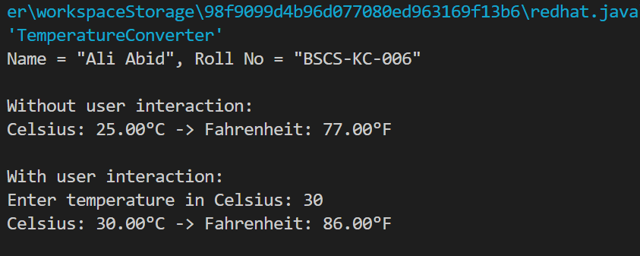
LAB 2
Explanation:
Check if a user-entered amount can be withdrawn based on the current balance. Print appropriate messages for available or unavailable funds.

Code:
import java.util.Scanner;

public class BalanceChecker {
public static void main(String[] args) {
// Print name and roll number (common statement)
System.out.println("Name = \"Ali Abid\", Roll No = \"BSCS-KC-006\"");

// Define the current balance
double currentBalance = 5000.00; // Example balance

// Take input
Scanner scanner = new Scanner(System.in);
System.out.print("\nEnter the amount to be drawn: ");
double amount = scanner.nextDouble();

// Check if the amount is available
if (amount <= currentBalance) {
System.out.println("Amount is available.");
} else {
System.out.println("Amount is not available.");
}

}
}

Output:
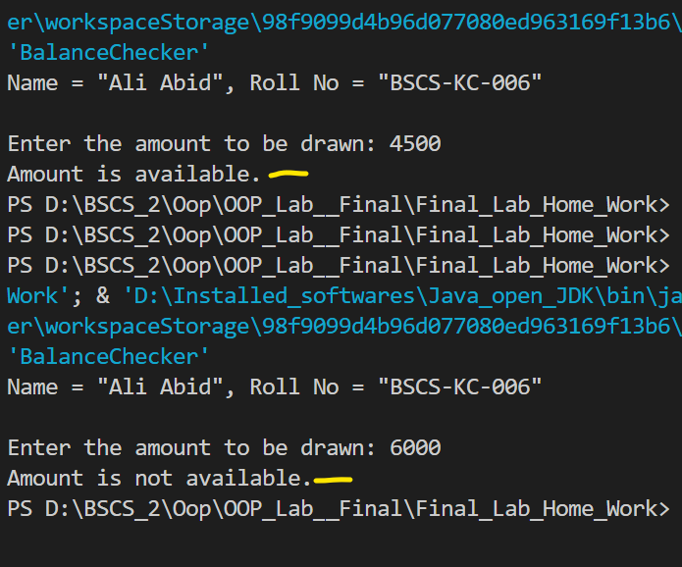
LAB 3
Explanation:
Use a while loop to prompt the user to select the correct answer from a list of choices for a question.

Code:
import java.util.Scanner;

public class QuizProgram {
public static void main(String[] args) {
// Print name and roll number (common statement)
System.out.println("Name = \"Ali Abid\", Roll No = \"BSCS-KC-006\"");

Scanner scanner = new Scanner(System.in);
int userChoice = -1;

// Display the question and answer choices
System.out.println("\nQuestion: What is the capital of Pakistan?");
System.out.println("1) Lahore");
System.out.println("2) Islamabad");
System.out.println("3) Karachi");
System.out.println("4) Peshawar");

// Correct answer
int correctAnswer = 2;

// While loop to prompt the user until they choose the correct answer
while (userChoice != correctAnswer) {
System.out.print("\nEnter your choice (1-4): ");
userChoice = scanner.nextInt();

if (userChoice == correctAnswer) {
System.out.println("Correct! The capital of Pakistan is Islamabad.");
} else {
System.out.println("Incorrect! Please try again.");
}
}
}
}

Output:
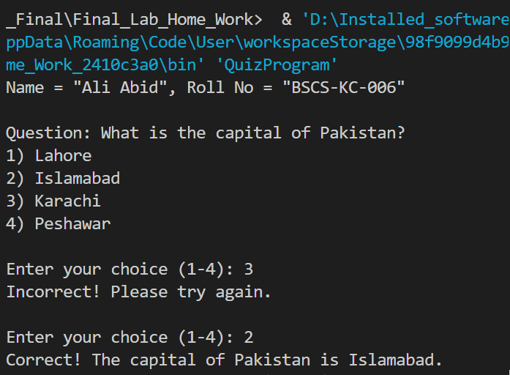

LAB 4
Explanation:
Create a class MyMath with a method to round numbers to the nearest hundredth. Use it in another class TryMyMath to calculate and display a number, its square, and cube.

Code:
public class MyMath {
// Static method to round a double to the nearest 100th
public static double roundToNearest100th(double number) {
return Math.round(number * 100) / 100.0;
}
}

public class TryMyMath {
// Method to print a number, its square, and its cube (all rounded to 100th)
public static void printNumberDetails(double number) {
double roundedNumber = MyMath.roundToNearest100th(number);
double roundedSquare = MyMath.roundToNearest100th(Math.pow(number, 2));
double roundedCube = MyMath.roundToNearest100th(Math.pow(number, 3));

System.out.println("Number (rounded to 100th): " + roundedNumber);
System.out.println("Square (rounded to 100th): " + roundedSquare);
System.out.println("Cube (rounded to 100th): " + roundedCube);
}

// Main method
public static void main(String[] args) {
// Print name and roll number (common statement)
System.out.println("Name = \"Ali Abid\", Roll No = \"BSCS-KC-006\"");

// Call printNumberDetails with Math.E
System.out.println("\nDetails for Math.E:");
printNumberDetails(Math.E);

}
}

Output:
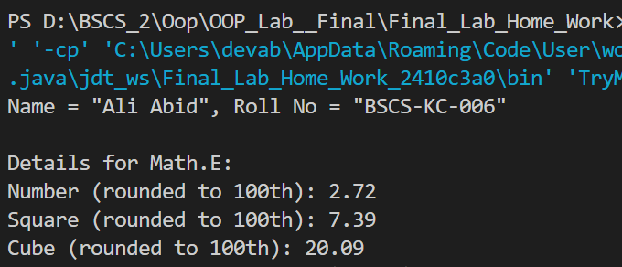

LAB 5
Explanation:
Simulate a bank account with features like deposits, withdrawals, interest rate settings, and balance checking. Demonstrate the account in action.

Code:
public class BankAccount {
private double balance;
private double interstate; // in percentage (e.g., 5 for 5%)

// Constructor to initialize the account with a starting balance
public BankAccount(double initialBalance) {
this.balance = initialBalance;
this.interestRate = 0; // Default interest rate
}
// Method to deposit money
public void deposit(double amount) {
if (amount > 0) {
balance += amount;
System.out.println("Deposited: " + amount);
} else {
System.out.println("Invalid deposit amount.");
}
}
// Method to withdraw money
public void withdraw(double amount) {
if (amount > 0 && amount <= balance) {
balance -= amount;
System.out.println("Withdrawn: " + amount);
} else if (amount > balance) {
System.out.println("Insufficient balance.");
} else {
System.out.println("Invalid withdrawal amount.");
}
}
// Method to set the interest rate
public void setInterestRate(double rate) {
if (rate >= 0) {
this.interestRate = rate;
System.out.println("Interest rate set to: " + rate + "%");
} else {
System.out.println("Invalid interest rate.");
}
}

// Method to add interest to the balance
public void addInterest() {
double interest = balance * (interestRate / 100);
balance += interest;
System.out.println("Interest added: " + interest);
}
// Method to get the current balance
public double getBalance() {
return balance;
}
}

public class Main {
public static void main(String[] args) {
// Print name and roll number (common statement)
System.out.println("Name = \"Ali Abid\", Roll No = \"BSCS-KC-006\"");

// Create a BankAccount object with an initial balance
BankAccount myAccount = new BankAccount(5000); // Initial balance: 5000

// Perform operations on the account
System.out.println("\nInitial Balance: " + myAccount.getBalance());
myAccount.deposit(1500); // Deposit 1500
myAccount.withdraw(2000); // Withdraw 2000
myAccount.setInterestRate(5); // Set interest rate to 5%
myAccount.addInterest(); // Add interest

// Display the final balance
System.out.println("Final Balance: " + myAccount.getBalance());

}
}

Output:
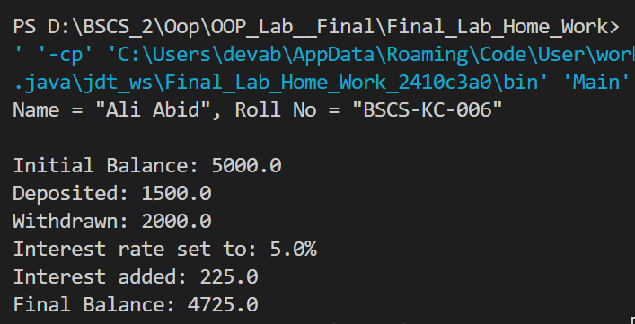
LAB 6
Explanation:
Create a Calculation class with methods for addition and subtraction. Take user input for variables and pass them to the methods for calculation.

Code:

import java.util.Scanner;

public class Calculation {
private double a;
private double b;

// Method to perform addition
public double Add() {
return a + b;
}

// Method to perform subtraction
public double Subtract() {
return a - b;
}

// Method to take user input for a and b
public void takeInput() {
Scanner scanner = new Scanner(System.in);

System.out.print("Enter the value for a: ");
a = scanner.nextDouble();

System.out.print("Enter the value for b: ");
b = scanner.nextDouble();
}
}

public class Main {
public static void main(String[] args) {
// Print name and roll number (common statement)
System.out.println("Name = \"Ali Abid\", Roll No = \"BSCS-KC-006\"");

// Create an object of Calculation
Calculation calc = new Calculation();

// Take user input for a and b
calc.takeInput();

// Perform addition and subtraction and display the results
System.out.println("\nAddition result: " + calc.Add());
System.out.println("Subtraction result: " + calc.Subtract());

}
}

Output:
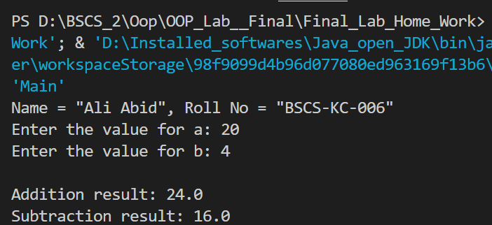

LAB 7
Explanation:
Use multilevel inheritance to create a program for generating a marksheet, calculating percentages and averages for different departments.

Code:
public class Student {
String name;
int rollNo;

// Constructor to initialize student details
public Student(String name, int rollNo) {
this.name = name;
this.rollNo = rollNo;
}

// Method to display student details
public void displayStudentDetails() {
System.out.println("Student Name: " + name);
System.out.println("Roll Number: " + rollNo);
}
}

public class Department extends Student {
String departmentName;

// Constructor to initialize department details
public Department(String name, int rollNo, String departmentName) {
super(name, rollNo);
this.departmentName = departmentName;
}

// Method to display department details
public void displayDepartmentDetails() {
System.out.println("Department: " + departmentName);
}
}

public class Marks extends Department {
double subject1, subject2, subject3, subject4, subject5;
double totalMarks = 500; // Assuming total marks for 5 subjects is 500

// Constructor to initialize marks
public Marks(String name, int rollNo, String departmentName, double subject1, double subject2, double subject3, double subject4, double subject5) {
super(name, rollNo, departmentName);
this.subject1 = subject1;
this.subject2 = subject2;
this.subject3 = subject3;
this.subject4 = subject4;
this.subject5 = subject5;
}

// Method to calculate total marks
public double calculateTotal() {
return subject1 + subject2 + subject3 + subject4 + subject5;
}

// Method to calculate percentage
public double calculatePercentage() {
return (calculateTotal() / totalMarks) * 100;
}

// Method to calculate average
public double calculateAverage() {
return calculateTotal() / 5;
}

// Method to display marksheet and calculations
public void displayMarksheet() {
displayStudentDetails();
displayDepartmentDetails();
System.out.println("Marks in Subject 1: " + subject1);
System.out.println("Marks in Subject 2: " + subject2);
System.out.println("Marks in Subject 3: " + subject3);
System.out.println("Marks in Subject 4: " + subject4);
System.out.println("Marks in Subject 5: " + subject5);
System.out.println("Total Marks: " + calculateTotal() + " / " + totalMarks);
System.out.println("Average: " + calculateAverage());
System.out.println("Percentage: " + calculatePercentage() + "%");
}
}

public class Main {
public static void main(String[] args) {
// Print name and roll number (common statement)
System.out.println("Name = \"Ali Abid\", Roll No = \"BSCS-KC-006\"");

// Create Marks object and initialize with student, department, and subject marks
Marks studentMarks = new Marks("Ali Abid", 12345, "Computer Science", 85, 90, 88, 92, 87);

// Display marksheet
System.out.println("\nMarksheet:");
studentMarks.displayMarksheet();

}
}

Output:
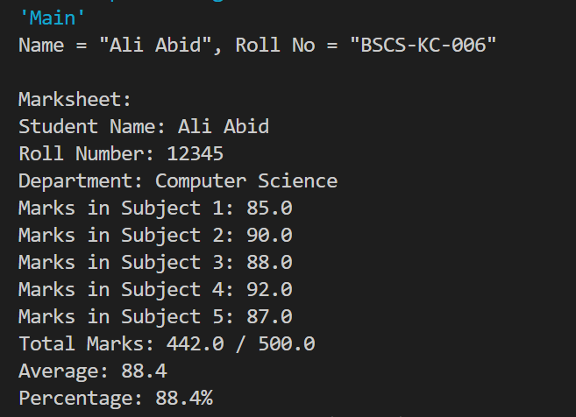

LAB 8
Explanation:
Create a Vehicle class with data members, constructors, and methods. Inherit Car and Bike classes, and override a virtual method to calculate speed.

Code:

abstract class Vehicle {
String model;
String color;
String engine;
int door;

// Default Constructor
Vehicle() {
this.model = "Unknown";
this.color = "Unknown";
this.engine = "Unknown";
this.door = 0;
}

// Parameterized Constructor
Vehicle(String model, String color, String engine, int door) {
this.model = model;
this.color = color;
this.engine = engine;
this.door = door;
}

// Method to start the vehicle
void start() {
System.out.println(model + " is starting...");
}

// Method to stop the vehicle
void stop() {
System.out.println(model + " is stopping...");
}

// Method to run the vehicle
void run() {
System.out.println(model + " is running...");
}

// Abstract method to calculate speed
abstract void calculateSpeed();

// Method to print vehicle information
void printInfo() {
System.out.println("Model: " + model);
System.out.println("Color: " + color);
System.out.println("Engine: " + engine);
System.out.println("Number of Doors: " + door);
}
}

class Car extends Vehicle {
// Constructor
Car(String model, String color, String engine, int door) {
super(model, color, engine, door);
}

// Override the calculateSpeed method
@Override
void calculateSpeed() {
System.out.println("The car's average speed is 120 km/h.");
}
}

class Bike extends Vehicle {
// Constructor
Bike(String model, String color, String engine, int door) {
super(model, color, engine, door);
}

// Override the calculateSpeed method
@Override
void calculateSpeed() {
System.out.println("The bike's average speed is 80 km/h.");
}
}

public class Main {
public static void main(String[] args) {
// Print name and roll number (common statement)
System.out.println("Name = \"Ali Abid\", Roll No = \"BSCS-KC-006\"");

// Create a Car object
Car car = new Car("Toyota Corolla", "White", "1.8L", 4);
System.out.println("\nCar Information:");
car.printInfo();
car.start();
car.run();
car.calculateSpeed();
car.stop();

// Create a Bike object
Bike bike = new Bike("Honda CB150F", "Red", "150cc", 0);
System.out.println("\nBike Information:");
bike.printInfo();
bike.start();
bike.run();
bike.calculateSpeed();
bike.stop();

}
}

Output:
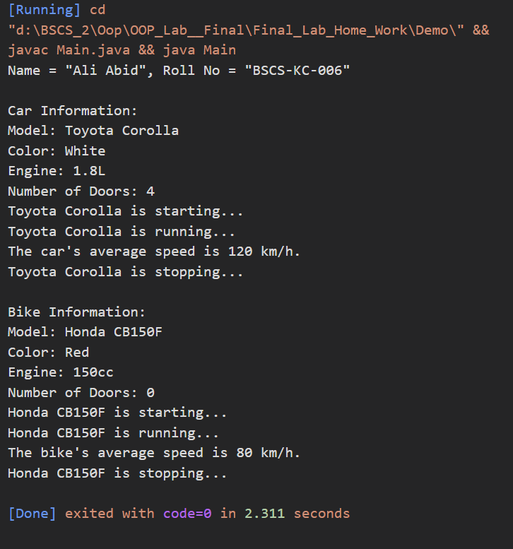

LAB 9
Explanation:
Write a program to print the elements of a string array using a function. Initialize the array in the main method and pass it to the function.

Code:

public class Main {
// Method to print array elements
static void printArray(String[] array) {
System.out.println("Array Elements:");
for (String element : array) {
System.out.println(element);
}
}

public static void main(String[] args) {
// Print name and roll number (common statement)
System.out.println("Name = \"Ali Abid\", Roll No = \"BSCS-KC-006\"");

// Initialize a string array
String[] stringArray = {"Java", "Python", "C++", "JavaScript", "Django"};

// Call the printArray method and pass the array
printArray(stringArray);

}
}

Output:
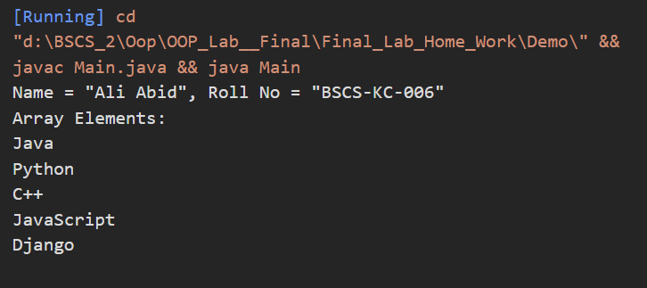
LAB 10
Explanation:
Implement an interface IShape with methods to input a shape name and calculate its area. Use if-else to handle different shapes like Circle, Rectangle, and Triangle.

Code:

import java.util.Scanner;

interface IShape {
void SName(); // Method to input the name of the shape
void ShArea(); // Method to calculate and display the area of the shape
}

class ShapeCalculator implements IShape {
private String shapeName;

// Method to input the name of the shape
@Override
public void SName() {
Scanner scanner = new Scanner(System.in);
System.out.print("Enter the name of the shape (Circle, Rectangle, Triangle): ");
shapeName = scanner.nextLine();
}

// Method to calculate and display the area of the shape
@Override
public void ShArea() {
Scanner scanner = new Scanner(System.in);
double area = 0;

if (shapeName.equalsIgnoreCase("Circle")) {
System.out.print("Enter the radius of the circle: ");
double radius = scanner.nextDouble();
area = Math.PI * radius * radius;
System.out.printf("The area of the Circle is: %.2f\n", area);
} else if (shapeName.equalsIgnoreCase("Rectangle")) {
System.out.print("Enter the length of the rectangle: ");
double length = scanner.nextDouble();
System.out.print("Enter the width of the rectangle: ");
double width = scanner.nextDouble();
area = length * width;
System.out.printf("The area of the Rectangle is: %.2f\n", area);
} else if (shapeName.equalsIgnoreCase("Triangle")) {
System.out.print("Enter the base of the triangle: ");
double base = scanner.nextDouble();
System.out.print("Enter the height of the triangle: ");
double height = scanner.nextDouble();
area = 0.5 * base * height;
System.out.printf("The area of the Triangle is: %.2f\n", area);
} else {
System.out.println("Invalid shape name entered!");
}
}
}

public class Main {
public static void main(String[] args) {
// Print name and roll number (common statement)
System.out.println("Name = \"Ali Abid\", Roll No = \"BSCS-KC-006\"");

// Create an object of ShapeCalculator
ShapeCalculator shapeCalculator = new ShapeCalculator();

// Input shape name and calculate area
shapeCalculator.SName();
shapeCalculator.ShArea();

}
}

Output:
